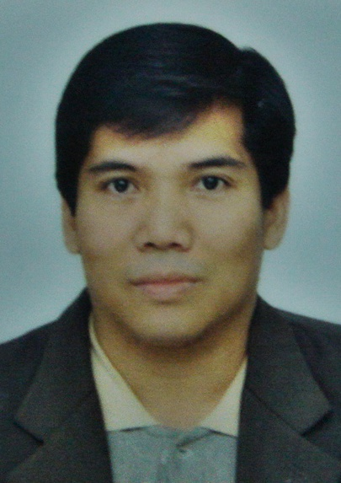
RONALDO C. SALTIVAN
Address:Blk 22lot 26 Villa Tanza Subd.
Brgy: Biga Tanza Cavite.
Philippines . 4108
Email: nhardz31@yahoo.com
Ym ID: nhardz31
Skype ID : nhardz31
Mobile # +8618929255063 China

OBJECTIVE:
To achieve goals, both personal and professional, that will help enhance my abilities with regards to my career, in alignment with what my organization expects of me.

PROFILE SUMMARY:
- Successfully set-up SMT production lines to 8 factories in Ningbo, Shenzhen, Jiangxi and Dongguan
Province China.
- Supervise, set-up and manage production lines
- Lean Manufacturing Practitioner
- Supports OTD, Quality and plant wide cost reduction programs
- Has 16 years working experience in Electronics and PCB manufacturing Company, AI/SMT machine installation and Production line setup.
- Experienced in Electromechanical machine such as Auto Insertion and SMT machine.
- Repair and Troubleshooting Electronics Consumer Products, Calibration AI/SMT and other manufacturing Equipment.
- 2nd class level Electronics Communication Technician.
- Experienced in Electronics Audio and Video trouble shooting.
- Computer literate and knowledge in trouble shooting and Software Installation.

SKILLS:
- Mandarin, English skills
- Quick Learner, willing to be trained
- Knowledge in Automatic Insertion and Surface Mount Technology Machine (Industrial machines)
- Can handle and Troubleshoot Electromechanical machines
- Can read and Understand Technical manuals and interpret schematic diagram and symbols.
- Computer literate, knowledge in Windows, MS-office, Internet and Other AI /SMT programs.
- Electronics, Audio, Video Troubleshooting.
- Electronics PCB Trouble shooting and modification

WORK EXPERIENCE:
Company Name: SUCCESS TECHNOLOGY March 10, 2004 TO PRESENT
Dongguan China
Position Held: FIELD SERVICE ENGINEER
Duties and Responsibilities:
- Responsible for installation, setup and preventive maintenance
of surface mount machine and other related machine used in
Electronics assy. (DONGGUAN, CHINA)
- Troubleshoot and repair machine board I/O card /power supply / Plc control system
- Maintenance and troubleshooting machine ( SMT)
- Production line monitoring ensuring and sustaining the good running condition of all machines.
- Software installation / Machine Calibration ( GSM and DEK 265 )
- Assist and train Technicians regarding Machine troubleshooting.
- Evaluate SMT Consumable parts.
Company Name: ASTEC POWER INC. January 5, 1998 – Sept 2001
Cavite, Philippines
Position Held: AI/SMT SR. MAINTENANCE TECHNICIAN
Duties and responsibilities:
- Monitor and request machine spare parts.
- Perform line and preventive maintenance in AI/SMT machines.
- Fabricate non critical machine spare parts for cost saving.
- Request machine tools and jigs.
- Production line sustaining and support.
- Assist every technician regarding machine troubleshooting.

Company Name: MAXON SYSTEMS (PHILS.) INC. August 1994 - September 1997
Cavite, Philippines
Position Held: SR. MAINTENANCE TECHNICIAN
Duties and Responsibilities:
- Perform line and preventive maintenance in Auto insertion machines.
- Production line sustaining and support.
- Replace worn-out parts.
- Perform machine calibration and set-up.
- Line monitoring.
- Train new technicians of proper maintenance procedure.
- Update machine data and daily downtime.
- Develops and implements plan.

EDUCATIONAL ATTAINMENT:
Electronics and Communication Technician
National Radio School Institute of Technology –Dagupan City, Pangasinan
Graduated October 1991

TRAINING/SEMINARS
- Fundamental system of insertion equipment
Universal Instrument Corporation = (Singapore 1/24/97)
- Advance maintenance and trouble shooting
Universal Instrument Corporation = (Singapore 1/30/97)
- FESTO Didactic seminar P-111 ( pneumatic control and design )
Astec Power Inc. (8/15 to 8/21 1998)

WELL VERSED IN COMPUTER PROGRAMS:
Application Software and Operating Systems, MS Windows 95/98/2000/2007, MS Word, MS Excel, Internet/E-mail applications.

PERSONAL DETAILS:
Age : 42 yrs. old
Sex: Male
Date of Birth: October 1, 1971
Citizenship: Filipino
Civil Status : Married
Height : 5’ 5”
SSS no. : 0101857877
Tin no. : 151-605-333
Passport no. : EB2856638

MACHINE PROFECIENCY:
- Universal dual head VCD machine (model 6295-A).
- Universal Sequencer machine (2596 a )
- Universal Axial Sequencer – Inserter (model 6241-b).
- Universal 2.5/5.0mm.radial lead (6368-E).
- Universal jumper wire inserter (6293b)
- Dynapert Emhart sequenser (UCSM-C and UCSM-G)
- Panasert HDP adhesive dispenser.
- Panasonic (Panasert MVII model )
- Juki chip mounter ke-730.
- Juki screen printer.
- Juki adhesive dispenser kd-780.
- Minami screen printer mk –880sv and 868sv.
- Asymtek adhesive dispenser.
- Siemens (high speed chip mounter hs-50 ).
- Fuji machine (CP642 , GL541 ,XP143 )
- Dek 265 LT/GS Screen printer
- Universal Machine GSM1 and GSMII

CHARACTER REFERENCES:

- Dominic Adrias: A/I Manager Astec Power Inc. ( PEZA ) Phils.
- Rolly Larazo : Manager Autoronix System Trading（Alabang )Phils.

I certify that the above information is valid and true.
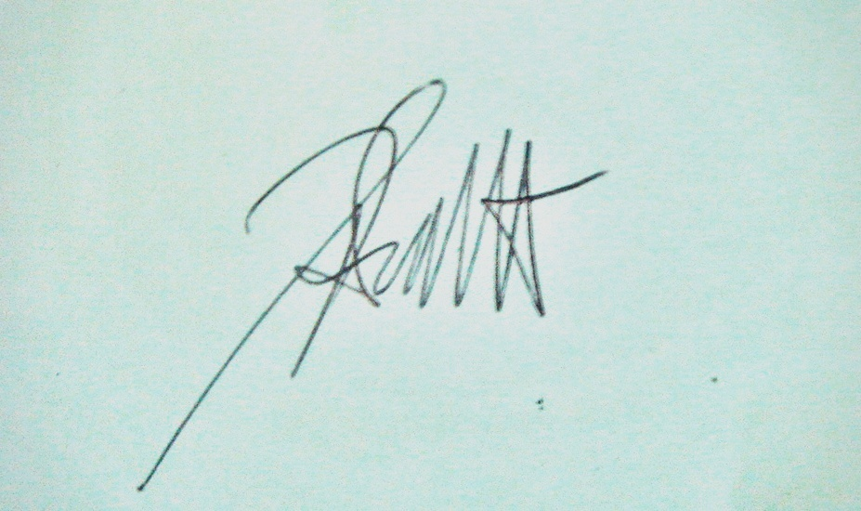

RONALDO C. SALTIVAN

