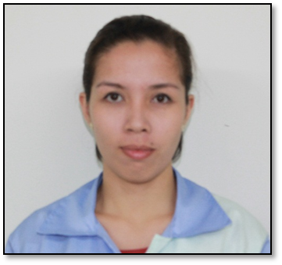
Louvinia B. Salinas

Home Address
Blk14 Lt24 Centennial Townhomes
Brgy. San Isidro, Cabuyao, Laguna

Mobile: +639285019151
E-mail: lovi.salinas@gmail.com

Personal Information:

SSS : 04-2706694-4
Philhealth : 080513723303
TIN : 316283954
Passport : EC4866750
Occupation : Engineer
Age : 26
Date of Birth : June 19, 1991
Marital Status : Single
Nationality : Filipino
Language : Tagalog / English

OBJECTIVE

To employ my knowledge and experience with the intention of securing a professional career with the opportunity for challenges and career advancement, while gaining knowledge of new skills and expertise.

WORK HISTORY

April 30, 2017 to present
Senior Programming Engineer
Katolec Philippines Corp.
103 East Main Avenue, Special Export Processing Zone Laguna Technopark, Biñan, Laguna

Job Responsibilities:

- Ensures that production schedule and delivery are being met.
- Ensures that product output meets the desired quality requirements.
- Ensures maximum and effective utilization of manpower resources, machines, and materials through proper handling.
- Monitors and ensures that production control parameters are being kept within the set target.
- Ensures proper implementation of quality system within his/her area of responsibility.
- Conduct performance evaluation to all his/her subordinates and implements disciplinary action when necessary.

May 17, 2013 to April 30, 2017
Programming Engineer
Katolec Philippines Corp.
103 East Main Avenue, Special Export Processing Zone Laguna Technopark, Biñan, Laguna

TECHNICAL SKILLS
- Computer Literate : Microsoft Office, Operating Systems
- Basic Programming Languages : VB 6.0, Java, Turbo C, HTML
- Basic PC troubleshooting, networking and installations
- Machine Programming (Yamaha Chip Mounters, Panasonic Machines, Solder Paste Inspection System, AOI Machines)

ON THE JOB TRAINING

General Telephone System, Inc.
December 05, 2012 – March 08, 2013
Sariaya, Quezon

EDUCATION

Tertiary Education

Bachelor of Science in Computer Engineering

June 2008 – April 2013
Manuel S. Enverga University Foundation Candelaria, Inc.
Candelaria, Quezon

Secondary Education
2003 – 2007
Manuel S. Enverga University Foundation Candelaria, Inc.
Candelaria, Quezon

Primary Education
2000 – 2006
Cabay Elementary School
Cabay, Tiaong, Quezon

CHARACTER REFERENCES

Mr. Felix Saldevia II
Assistant Manager – Katolec Phils.
Email: felix.saldevia@katolec.com.ph

Mrs. Airene E. Isabedra
Faculty Member – MSEUFCI
Candelaria, Quezon

