Process Control for Solder Flux

Stacy Kalisz Mark Owen
Sr. Applications Specialist Advanced Product Manager
MVTechnology Ltd. MVTechnology Ltd.
Gilbert, Arizona Beaverton, Oregon
skalisz@mvt.ie marko@mvt.ie

Abstract
Flux used in ball grid array (BGA) and chip scale package (CSP) manufacturing has been increasing in importance with requirements to hold smaller solder balls in place, adequately clean solder surfaces, and leave no residues. It is known in the packaging industry that insufficient or excess flux can cause a variety of defects however, a non-destructive process control tool capable of properly setting up and monitoring production parameters for flux dispense has not been available. It is difficult to measure a non-Newtonian, temperature sensitive, transparent, viscous fluid in-situ. Crude sampling measurements based on microscopes or weighing scales are in use on the manufacturing floor. This paper reviews a new technique called “fluorescence intensity mapping” which accurately measures flux location, height and volume of flux deposits.

1.0 Introduction

The use of flux within solder paste or within a wave soldering machine is well established in electronics manufacturing. More recently, the array packages (BGA/CSP, flip chip, etc.) have created additional requirements for new processes to apply flux by stencil printing, pin transfer, dispensing, dipping and jetting. The requirements for this flux application process are as follows:

- Tack -Apply enough flux to retain 300-762 μm solder balls in place during reflow.
- Solderability - Apply enough flux to remove oxides on the solder balls and board pads.
- Residues- Limit residues by applying an appropriate amount of flux which will activate and burn off during reflow.
- Barrier Effect –Apply flux such that a “flux barrier effect” which blocks the seating and soldering of solder balls or array components does not occur.
- Contamination- Apply a controlled amount of flux such that smears and contamination with the surrounding solder mask are avoided.
- Process Capability - Apply a repeatable quantity of flux despite ambient variations.
- Printability – Apply flux consistently to avoid stencil aperature build-up or blockages.

Process control is needed for flux deposition however, monitoring flux is difficult for several reasons:
- Flux is a non-Newtonian liquid, that is, its viscosity changes with the speed at which it is worked.
- Flux viscosity changes dramatically with ambient temperature and moisture.
- Screen printing tends to work air bubbles into the flux [Figure 1].
- Solder fluxes are nearly transparent unstable fluids unsuitable for standard optical solutions.
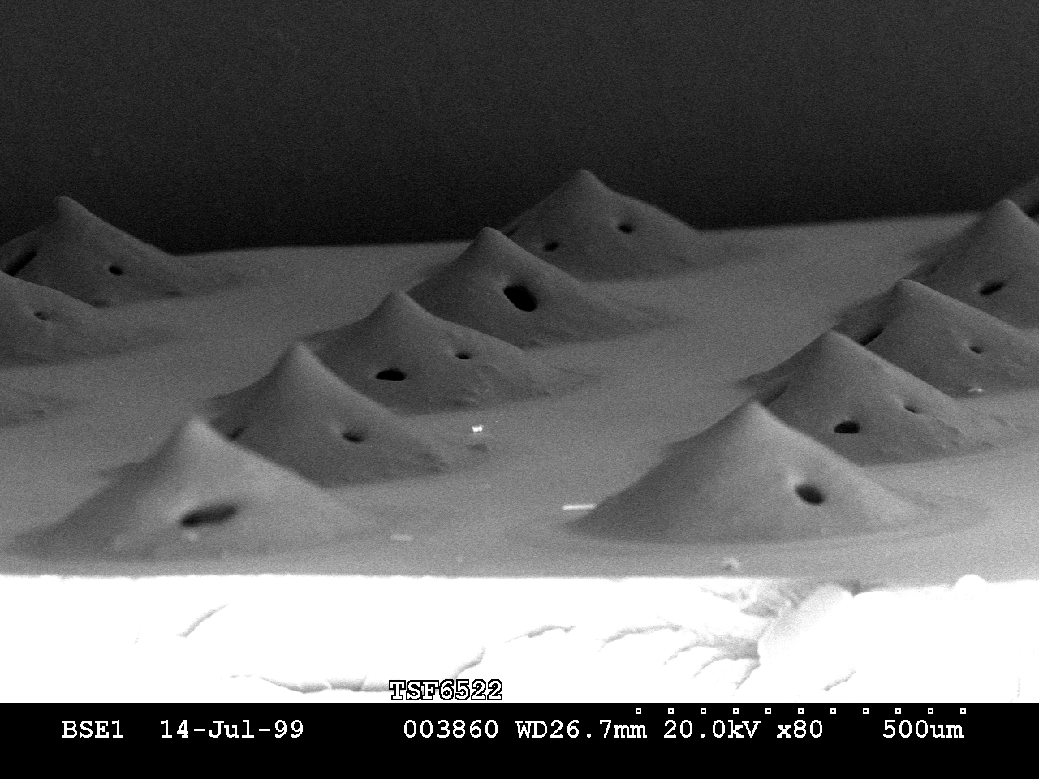

Figure 1 Scanning Electron Microscope (VPSEM) image of flux deposits on a test substrate showing that air is trapped within deposits at deposition.

Despite these issues, researchers at Motorola, Delphi, Philips, Indium, and others have shown:
- There is a correlation between flux thickness and ball location offsets [1], the number of missing balls at reflow [2], defect rates at ball attach [3], and to an increase in solder ball voids [4,5,6].
- Excess flux volume can interact with solder mask to cause residues which increase migration between adjacent solder joints, and result in unacceptable residues around or under components.
- For flip chip soldering, <25 micron thickness did not account for ball height variations, and >70 microns affected placement accuracy [7]. Other researchers [8] refined this by looking at flux residues, underfill adhesion issues, soldering requirements, and reliability and determined that a 20 micron minimum and 50 micron nominal thickness was recommended based on the solder ball coplanarity specification and the solder ball height.
- Measurement tools available were inadequate to measure to the tolerance required [1].

These issues prompted MV Technology Ltd. to investigate methods for measuring flux in cooperation with Motorola, which led to the development of the patent pending ultraviolet fluorescent intensity mapping technique (UV FIM) [9].

- The Technology of Flux Measurement

Potential techniques for solder flux inspection and measurement

Figure 2 shows the techniques commercially available that could possibly address solder flux inspection. As summarized in the figure, UV FIM is the most practical technique available for this type of inspection based on speed and capability.
Figure 2 The 2D/3D measurement techniques evaluated.

The UV FIM process uses ultraviolet light to stimulate a fluorescent emission from standard fluxes which can be calibrated to correlate to a thickness measurement. The ultraviolet light stimulates double bonds in the active acids within the flux, and has been shown to work for nearly two dozen fluxes by a four different solder paste/flux manufacturers. The UV FIM technique has been incorporated into an automated inline inspection system, the FX-10, as shown in Figure 3.

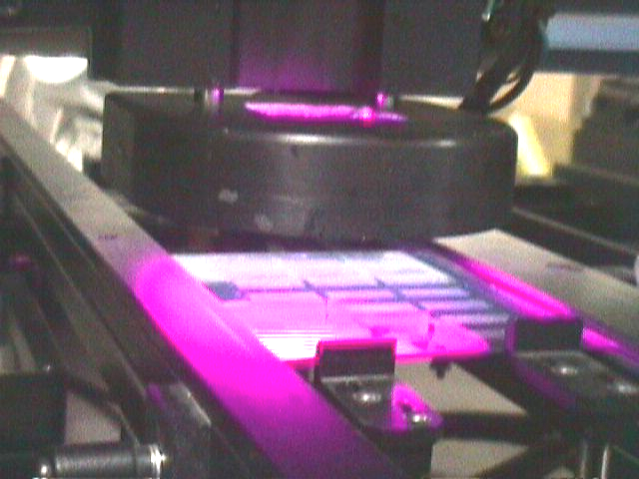
UV LEDs

Part under test on conveyor. System corrects for copper reference level and autoscales for max flux sensitivity

Built in Fluorescence Standard - intensity readings verified at the beginning of each inspection.

Figure 3 The FX-10 used inline before the ball attach process CSP/BGA manufacture allows automated inspection and process control.
Using the UV FIM technique coupled with machine vision techniques, all the deposits within a field of the view of a camera can be measured as shown in Figure 4.

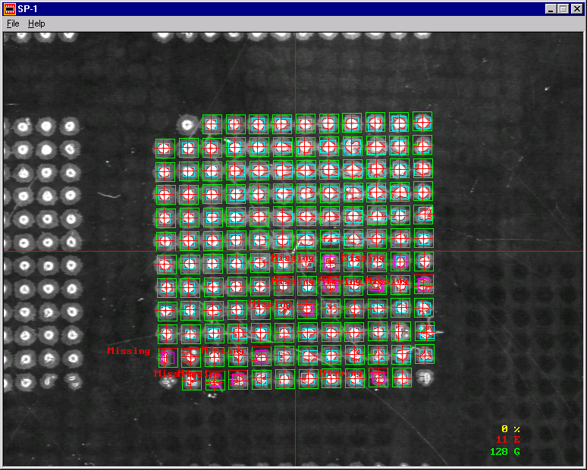

Figure 4 The FX-10 captures a high quality image of a region of deposits (a), uses vision algorithms and the UV FIM technique to analyze the deposits (b), and provides accurate 3D data which can be displayed using standard tools (c).

Flux Measurement for Process Control
Using the FX-10 system, researchers [9] have shown the UV FIM technique has the capability to:

- Measure flux location, height and volume of tacky fluxes used in ball attach as shown in Figure 5.
- Measure paste and flux location and thickness in flip chip on board applications as shown in Figure 6.
- Achieve a gage repeatability and reliability (GR&R) on volume and height <10%.
- Measure flux volume inline with the normal process flow at a rate > 3 CSP’s devices/seconds.

Figure 5 Inline flux measurement using the UV FIM technique within the solder ball attach process can measure the location, thickness, and volume of every deposit on a device at a rate of >3 devices per second and with a GR&R <10% on all measurements.

Figure 6 Using the UV FIM technique in an SMT line with flip chip on board components allows 2D solder paste and 2D/3D solder flux measurement on the location and area of every paste deposit and the location, thickness, and volume of every flux deposit even at high volume SMT line rates.

The FX-10 is being used inline in a flip chip on board application in an automotive electronics module division of Delphi. The system is used after the screen printing of paste and flux, but before the components have been placed, as shown in Figure 6. The system detects both the paste and flux deposits at this process point, as shown in Figure 7.

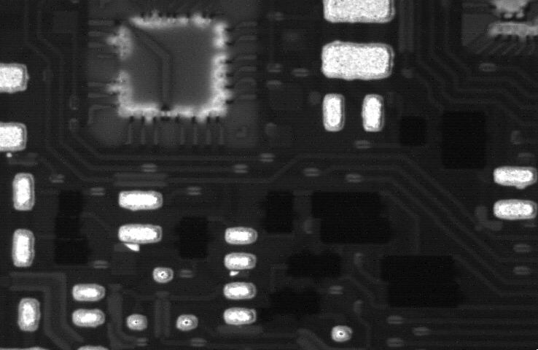

Figure 7 A screen image of the FX-10 shows paste deposits for the SMT components

and flux deposits for the flip chip component on the same panel.

A bridge of paste has been identified in the bottom corner.

- Conclusions

Solder flux inspection using the UV FIM technique is a useful and accurate process control tool for BGA/CSP ball attach and flip chip on board manufacture.

- References
- “Impact of Flux Height Deposit on Pre-Reflow Sphere Registration”, an internal Motorola CSP Process Characterization Study, by Chris Clark, Aug 7, 1998.
- “Solder-Ball Manufacturing and Attachment for BGA” Panel Discussion Presentation in BGA Symposium, Nepcon West 1997.
- “Soldering Technology for Area Array Packages” by Dr. Ning-Cheng Lee and William Casey, SMTA ’99, pp 282-297.
- “Voiding in BGA at Solder Bumping Stage”, by Dr. Chingehen S. Chiu, et.al. pp. 462-471, ISHM 1997.
- “Voiding Mechanism in BGA Assembly”, ISHM 1995.
- “Reduction of BGA Eutectic Ball Solder Joint Voiding” by William Casey, SMI ’98, pp 541-548.
- “Process Limit Testing on Fluxes used for Flip Chip Soldering: by Novak et al, SMI ’98, pp 275-280.
- “Verification of Flip-Chip Assembly on FR4 Boards”, by Caroline Beelen and Martin Verguld, Soldering and Surface Mount Technology, 10/3 [1998] pp 23-28.
- “Inline Flux Volume Measurement for CSP Process Control” by Stacy Kalisz,
Adrian Boyle, Niall Dorr and Mark Owen, Pan Pacific Symposium, Jan 2000.

