A Bus Planning Algorithm for
FPC Design in Complex Scenarios_2_Preliminaries

II. Preliminaries

- Terminologies

An industrial complex FPC board is shown in Fig.2, the pin area is distributed around the central area, and different areas are connected through channels. Mean- while, the connection between different areas is similar to bus routing, and engineers also refer to this feature when routing.

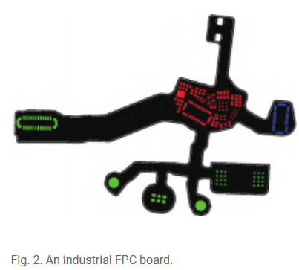

According to the characteristics of FPC, the PAI model shown in Fig.3 can be obtained by using a hierarchical clustering algorithm and some geometric pro- cessing. PAI ensures that most pins are concentrated in a certain number of areas, and there are no or only a few pins in the channel. The pin area is further divided into the side pin area (SPA) and center pin area (CPA); the number of CPA might be zero in some in- dustrial complex FPC.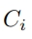 is the channel, 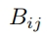is the bus that 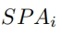 to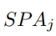 , 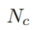is the single net that belongs to CPA, L is the layer, BL is the boundary line between pin areas and the channel. For SPA, there is one and only one boundary line.

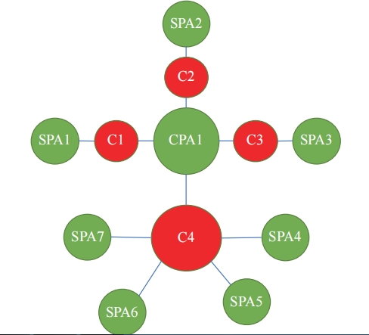
Fig.3.PAI model,which is an undirected graph

2. Problem Formulation

FPC is suitable for divide and conquer from the PAI model. The whole board routing problem can be divided into the pin area internal rout- ing subproblem and the channel routing subproblem. The routing flow of a single net is transformed into starting pin to CP and CP to the ending pin. The CPs are on the area boundary, and the resource distribution within the pin area and the channel is reflected in the location selection of the CPs. Finally, the complex FPC bus planning problem can be described as follows: Given a board, divide it into some SPAs and CPAs, consider resource distribution and routability by optimizing the selection of CP location, output the 3D coordinate of the CPs, which are on the corresponding BL. The X and Y coordinate are the locations of CP in the cur- rent layer while Z axis is the layer. Net in each region only corresponds to one CP. The PAI model is a representative model in FPC. The observation of several actual industrial FPC boards conforms to the description of this model.

